
Work Instruction for Filesystem add and extension in Linux

Viatris
Work Instruction for
Filesystem add and extension in Linux

Contents
Contents 2
1. Introduction 3
1.1. Purpose 3
1.2. Scope of this Report 3
1.3. Audience 3
2. Approach and Methodology 3
2.1 Approach 3
2.2 Methodology 3
3. Technical Details 3
3.1. Step 1 3
3.2. Step 2 5
4. Roles and Responsibilities 8
5. Escalation Matrix 8
6. Related Documentation 9
6.1. Additional Documentation 9
7. Revision History 9

1. Introduction

1.1. Purpose
This document will provide the procedure to be followed while Filesystem add and extension in Linux based on the requirement

1.2. Scope of this Report
The scope of a filesystem add/extension in Linux depends on the specific goals and requirements of the project.

1.3. Audience
GIDC Unix Group

2. Approach and Methodology

2.1 Approach

2.2 Methodology

3. Technical Details

3.1. Step 1
Adding new filesystem in Linux (Physical Servers/OS Filesystems)
3.1.1 Adding disk from VM
#Login to the Vcenter and find host where we have to add disk, then assign the disk for that server
3.1.2 once disk add to server, login to server and check newly added disk
#fdisk -l
3.1.3 once we found new disk and do disk the LVM partition
#fdisk /dev/sdXXXXXX
3.1.3.1 To Create new partition Press n.
3.1.3.2 Choose primary partition use p.
3.1.3.3 Choose which number of partitions to be selected to create the primary partition.
3.1.3.4 Press 1 if any other disk available.
3.1.3.5 Change the type using t.
3.1.3.6 Type 8e to change the partition type to Linux LVM.
3.1.3.7 Use p to print the create partition (here we have not used the option).
3.1.3.8 Press w to write the changes.
3.1.4 if the new disk size is more than 2TB, Partition the disk with parted command.
# parted /dev/sdX
GNU Parted 2.1
Using /dev/sdX
Welcome to GNU Parted! Type 'help' to view a list of commands.
(parted) mklabel gpt
(parted) mkpart primary 2048 100%
Warning: The resulting partition is not properly aligned for best performance.
Ignore/Cancel? I
(parted) q
Information: You may need to update /etc/fstab.
3.1.5 create pv on new disk
#pvcreate </dev/sdXXXXXXX>
3.1.6 check pv created are not
#pvs
#pvdisplay
3.1.7 Extend the vg with new pv (or) create the new vg
#vgextend <vgname> </dev/sdXXXXX>
(or)
#vgcreate <new vgname> <pvname /dev/sdXXX)
3.1.8 check vg extended or not
#vgs or vgdisplay
3.1.9 create the LV
#lvcreate -L +<size> -n <lv_name> <vg_name>
3.1.10 check the lv create or not
#lvs
3.1.11 create the local directory
#mkdir /datafs
3.1.12 change ownership and permission of the directory
#chown sap: sap /datafs
#Chmod 655 /datafs
3.1.13 Format the LV
#mkfs.ext4 /dev/mapper/datavg-datalv (If the filesystem type is ext4)
#mkfs.xfs /dev/mapper/datavg-datalv (If the filesystem type is XFS)
3.1.24 Mount the file system
#mount /mapper/datavg-datalv /datafs
(or)
#vi /etc/fstab
/dev/mapper/datavg-datalv /datafs ext4 defaults 0 0
Or
/dev/mapper/datavg-datalv /datafs xfs defaults 0 0
#mount -a
3.1.13 check the file system mounted or not
#df -Th /datafs
#ls -ld /datafs

Sample Change:

3.2. Step 2
Adding new filesystem in Linux (Non OS Filesystems Virtual Servers – Automation)

3.2. Step 2
Increase existing Filesystem
3.2.1 Adding disk from VM
#login to EXI host and find host where we have to add disk, then assign the disk for that server
3.2.2 once disk add to server, login to server and check newly added disk
#fdisk -l
3.2.3 once we found new disk and do disk the LVM partition
#fdisk /dev/sdXXXXXX
3.2.3.1 To Create new partition Press n.
3.2.3.2 Choose primary partition use p.
3.2.3.3 Choose which number of partitions to be selected to create the primary partition.
3.2.3.4 Press 1 if any other disk available.
3.2.3.5 Change the type using t.
3.2.3.6 Type 8e to change the partition type to Linux LVM.
3.2.3.7 Use p to print the create partition (here we have not used the option).
3.2.3.8 Press w to write the changes.
3.2.4 If the size of the disk is more that 2 TB, Partition the disk with parted command.
# parted /dev/sdX
GNU Parted 2.1
Using /dev/sdX
Welcome to GNU Parted! Type 'help' to view a list of commands.
(parted) mklabel gpt
(parted) mkpart primary 2048 100%
Warning: The resulting partition is not properly aligned for best performance.
Ignore/Cancel? I
(parted) q
Information: You may need to update /etc/fstab.
3.2.5 create pv on new disk
#pvcreate </dev/sdX>
3.2.6 check pv created are not
#pvs
#pvdisplay
3.2.7 Extend the vg with new pv
#vgextend <vgname> </dev/sdX>
3.2.8 check vg extended or not
#vgs or vgdisplay
3.2.8 extend lv and increase the file system
#lvextend -L +<size> </dev/mapper/datavg-datalv > -r
(or)
#lvextend -L +<size> </dev/mapper/rootvg-tmplv>
#resize2fs </dev/mapper/rootvg-tmplv> (If the filesystem type is ext4)
#xfs_growfs /dev/mapper/datavg-datalv (If the filesystem type is XFS)
3.2.9 check FS size extended or not
#df -hT <FS name>
Increase Existing Filesystem (Non-OS Filesystems Virtual Servers – Automation)
3.2.1 Need to create catalog request for Filesystem Add / Extend for virtual servers.
3.2.2 Provide the hostname of the server in which server we need to add/increase the filesystem.
3.2.3 Click on “Add” button. It will ask us “Add new mount point” or “Extend Existing Mount Point”. We need to choose as per our requirement.
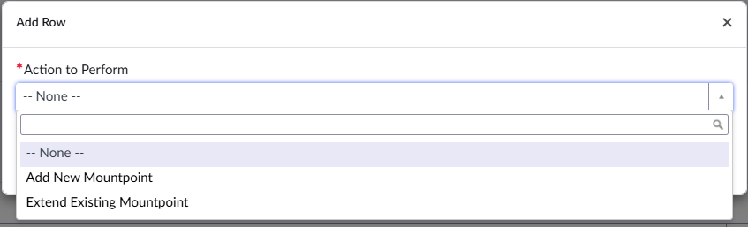
3.2.4 If we choose Extend Existing Mount Point” it will ask the filesystem name and size (in GB) how much you want to increase.
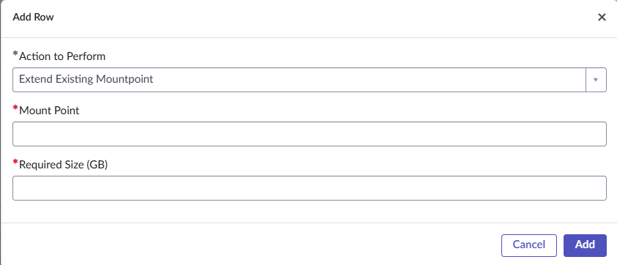
3.2.5 Fill the data and click on “Add” button.
3.2.6 Choose the vCenter name where the VM was residing.
3.2.7 Provide “Planned Start Date” when you want to implement the change.
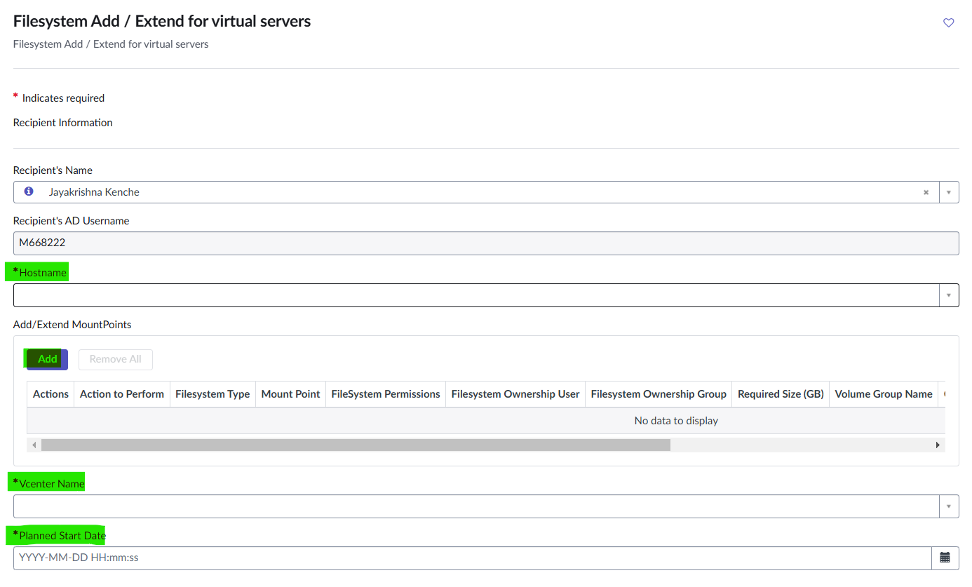
3.2.8 Once all the data filled correctly click on “Submit” button.
3.2.9 Automation BOT will pick the request and it will create change accordingly.
3.3.0 Change will implement as per the “Planned Start Date”.

Backout plan
For ext4 filesystems
1. check file system accessing for the users.
#lsof /mnt
Note: any application users or some other user using the file system we have to inform and get downtime
2. Before starting, we have to take the backup for the file system.
3. unmount the file system
#umount /datafs
#e2fsck /dev/mapper/datavg-datalv
4. Reduce the file system.
#resize2fs /dev/mapper/datavg-datalv 10GB (where 10G is the approximate total size of LV after reduction)
5. Reduce the Logical Volume size than Current size.
#lvreduce -L -10G /dev/mapper/datavg-datalv
6. Recheck the file system for error.
#resize2fs /dev/mapper/datavg-datalv
7. Remount the file-system back to stage.
#mount /dev/mapper/datavg-datalv /datafs
Sample change:

For XFS filesystems
1. check file system accessing for the users.
#lsof /datafs
Note: any application users or some other user using the file system we have to inform and get downtime
2. Before starting, we have to take the backup for the file system.
#xfsdump –f /usr/admin/datalv.dump /datafs
3. unmount the file system
#umount /datafs
4. Reduce the partition size
#lvreduce –L 10G /dev/mapper/datavg-datalv
5. Format The Partition With XFS Filesystem
#mkfs.xfs –f /dev/mapper/datavg-datalv
6. Remount the partition
#mount /dev/mapper/datavg-datalv /datafs
7. Restore the data
#xfsrestore –f /usr/admin/datalv.dump /datafs

4. Roles and Responsibilities
Sl. No. | Roles | Responsibilities | Team Member Name
1. | Maintenance Window | Respective Team / Unix Team | GIDC.unix_Run  GIDC.unix_Run@viatris.com
2. | Change Request | Respective Team / Unix Team | GIDC.unix_Run  GIDC.unix_Run@viatris.com
3. | Change Implementation | Respective Team / Unix Team | GIDC.unix_Run  GIDC.unix_Run@viatris.com
4. | Hyper Care | Respective Team / Unix Team | GIDC.unix_Run  GIDC.unix_Run@viatris.com

5. Escalation Matrix
Person Responsible | Role | Triggers When
Arun R  Arun.R@viatris.com  +91 9710677240 | SME
Ashok Kumar R K  AshokKumar.RK@viatris.com  +91 9967735890 | Manager
Zahir Hussian M  zahirhussain.m@viatris.com  +919840689462 | Senior Manager

6. Related Documentation

6.1. Additional Documentation

7. Revision History

Date | Version | Summary of Changes | Author | Approved by
May 19 2021 | V1.0 | Updated Organization Detail | Franklin Kabila Dhas | Arunachalam G
Apr 5 2023 | V1.1 | Updated in New Template | Ashok Kumar RK | Mohandoss Murugesan
Jan 30 2024 | V1.2 | Updated Technical Details | Jayakrishna Kenche | Arun R
Mar 03 2025 | V1.1 | Validated the Document | Chethan J | Arun R

